Data Lake

Exercise: [Create & query Azure Data Lake Analytics - Azure portal | Microsoft Docs](https://docs.microsoft.com/en-us/azure/data-lake-analytics/data-lake-analytics-get-started-portal)

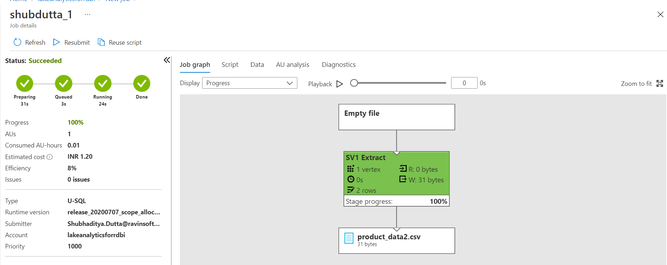

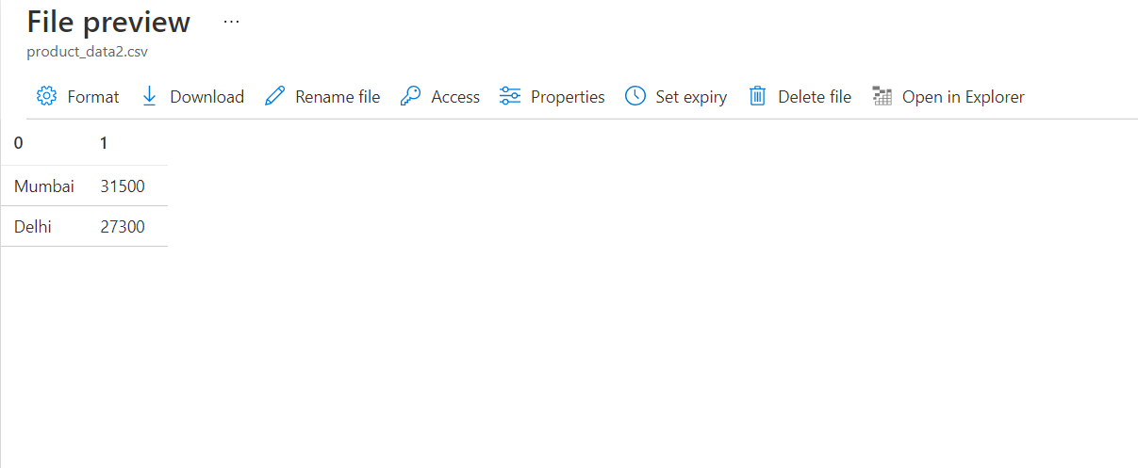

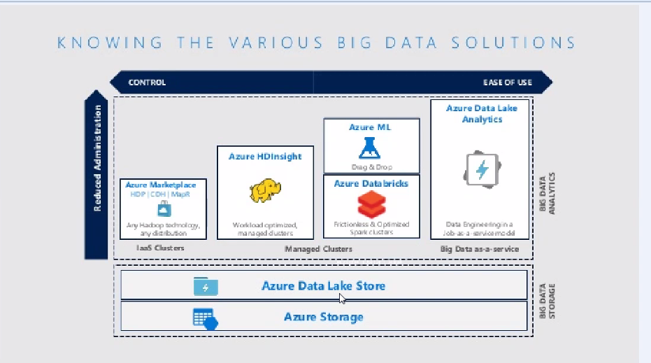

Power BI in Azure Synapse

[Quickstart: Linking a Power BI workspace to a Synapse workspace - Azure Synapse Analytics | Microsoft Docs](https://docs.microsoft.com/en-us/azure/synapse-analytics/quickstart-power-bi)

Azure ML Studio

[Experiments - Microsoft Machine Learning Studio (classic) (azureml.net)](https://studio.azureml.net/Home/ViewWorkspaceCached/59d7ad4735684556a4c6614998603575#Workspace/Experiments/SampleExperiments)

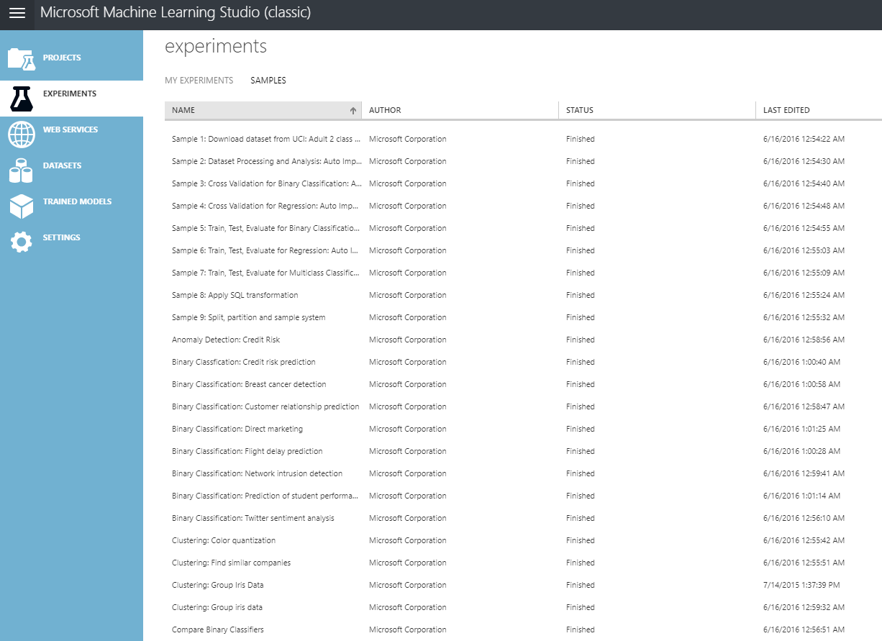

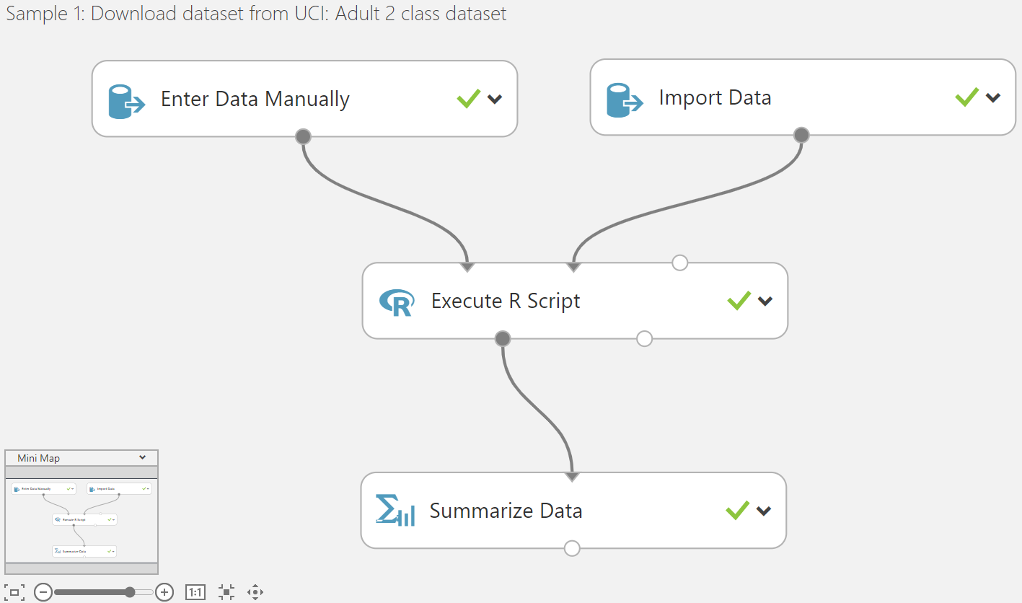

Data Bricks

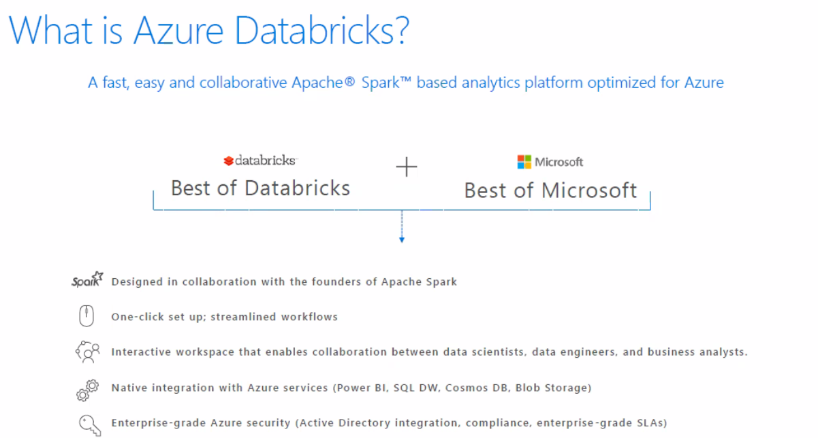

Why Databricks?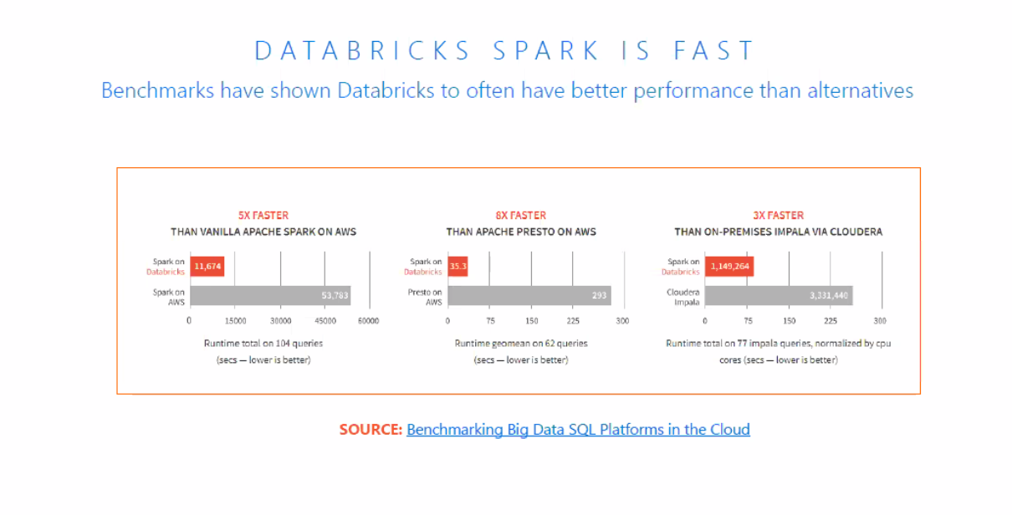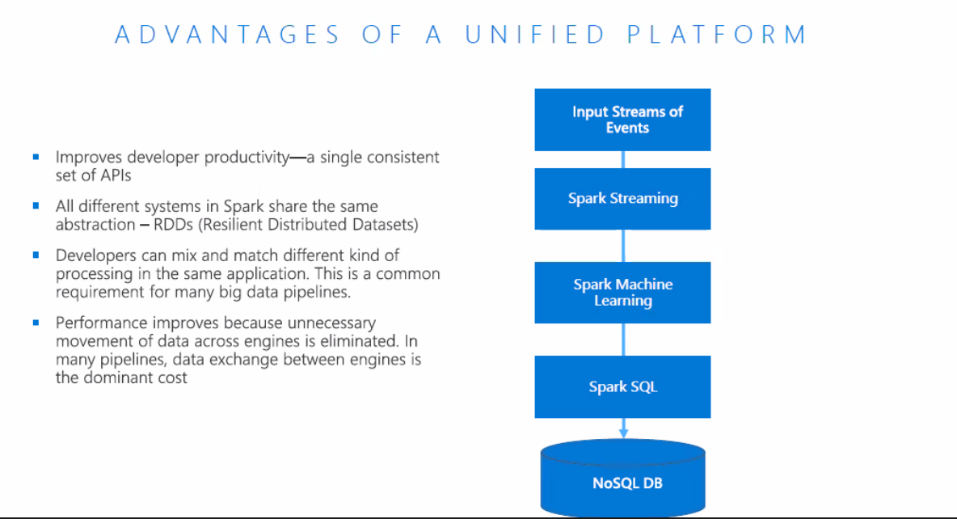

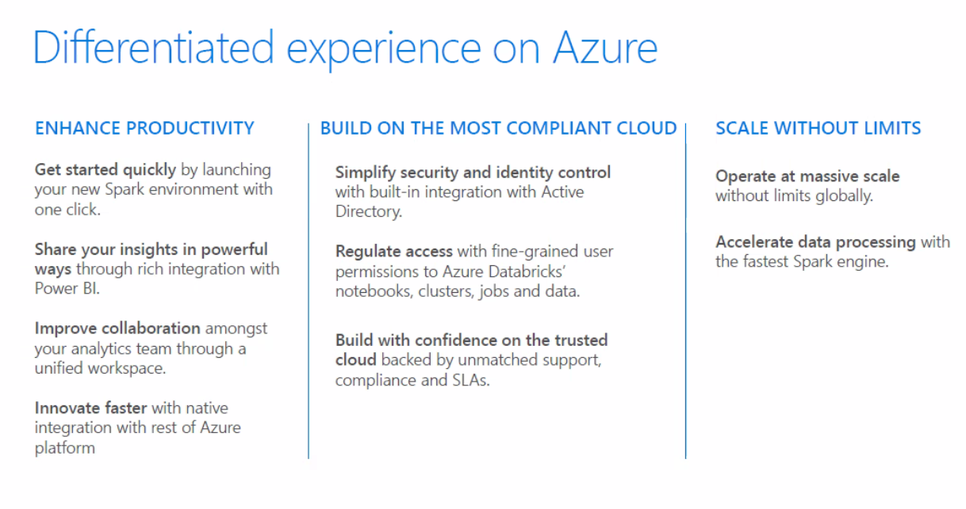

Flow

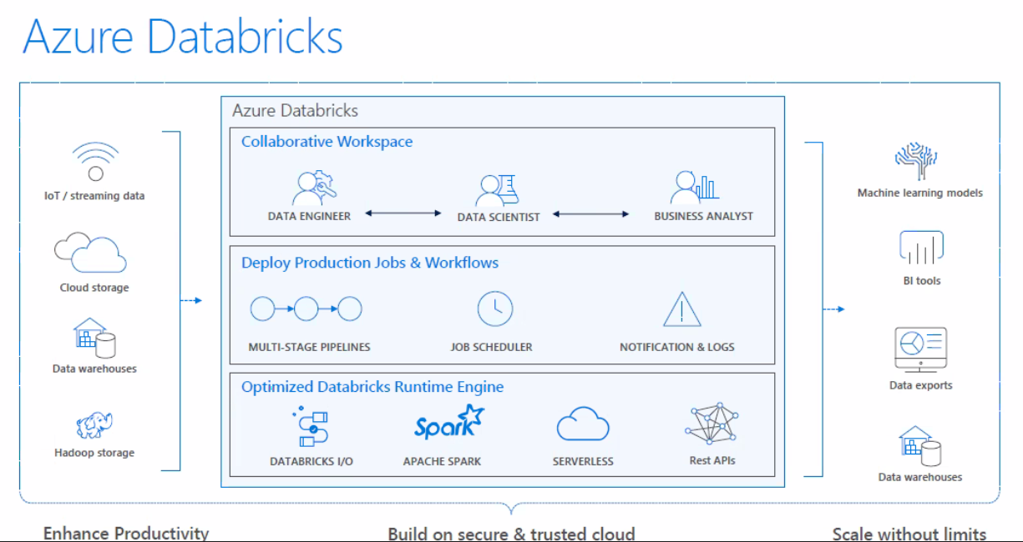

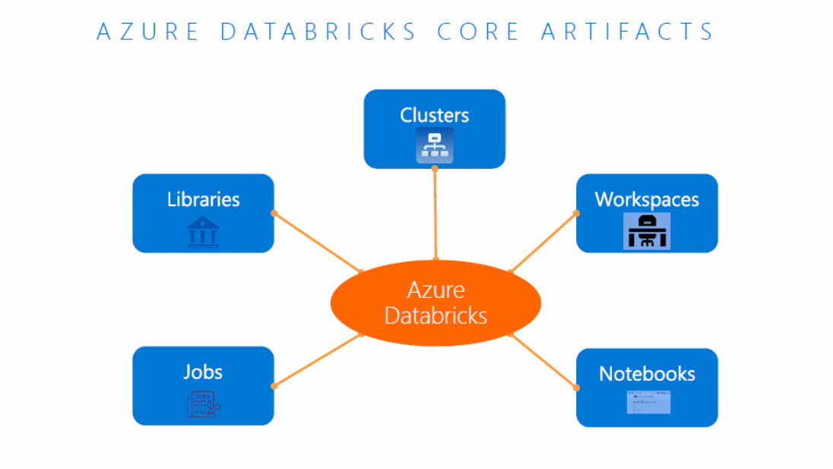

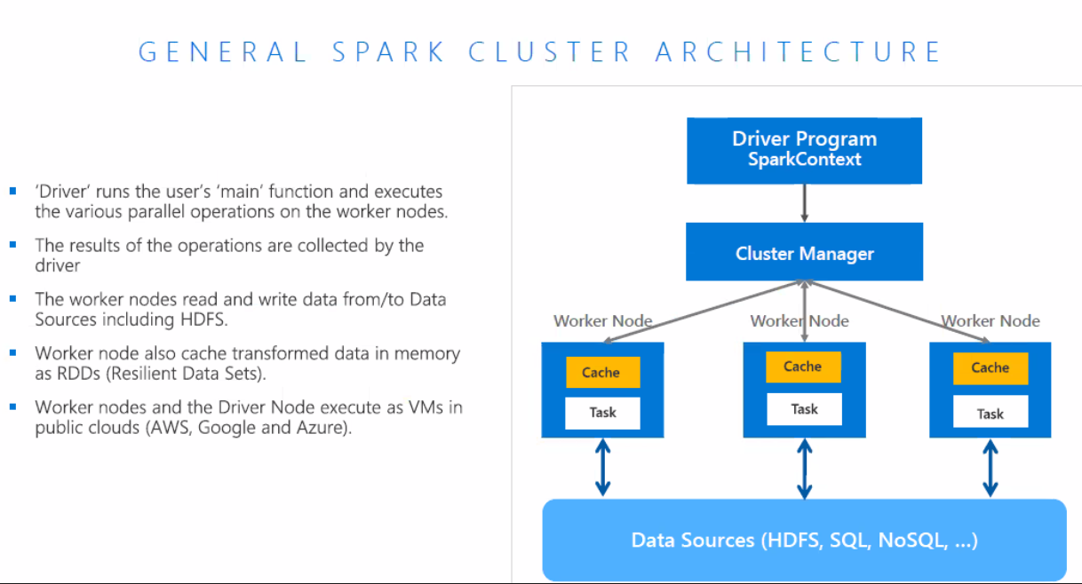

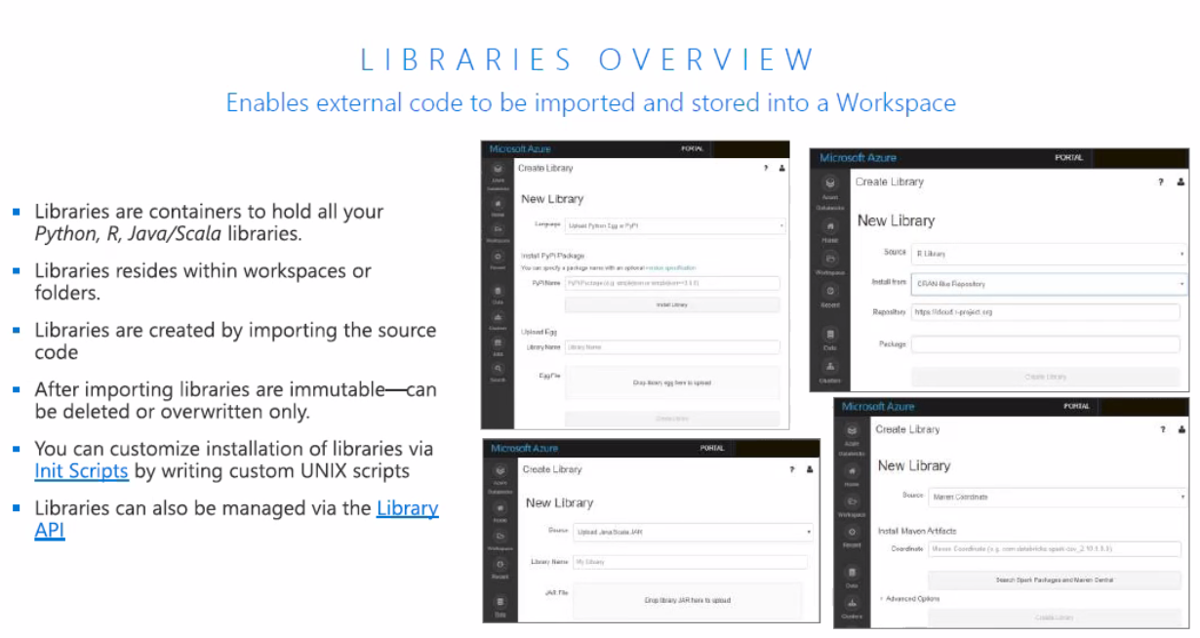

Hands On:

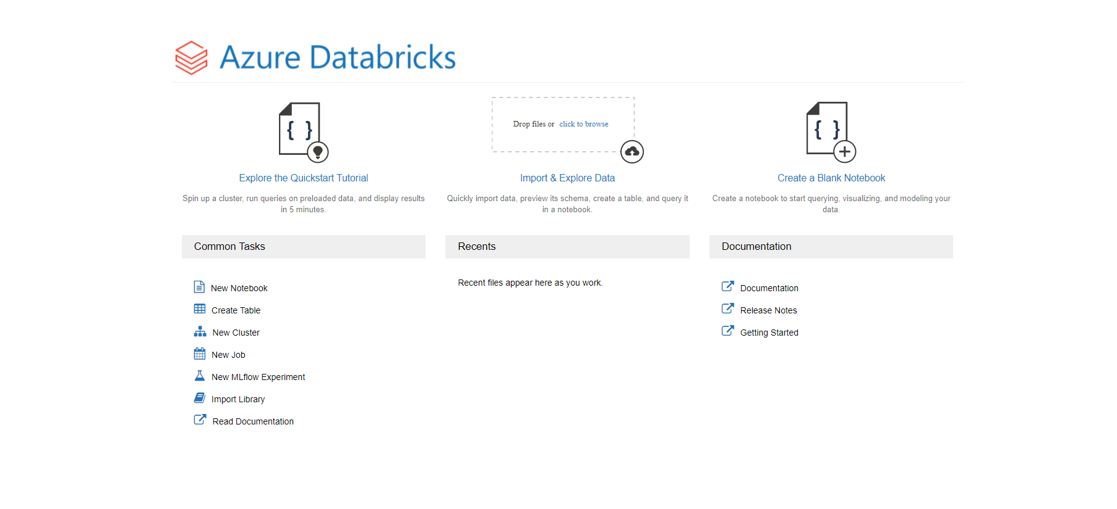

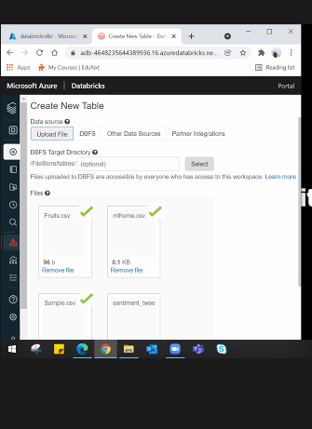

Example on Databricks

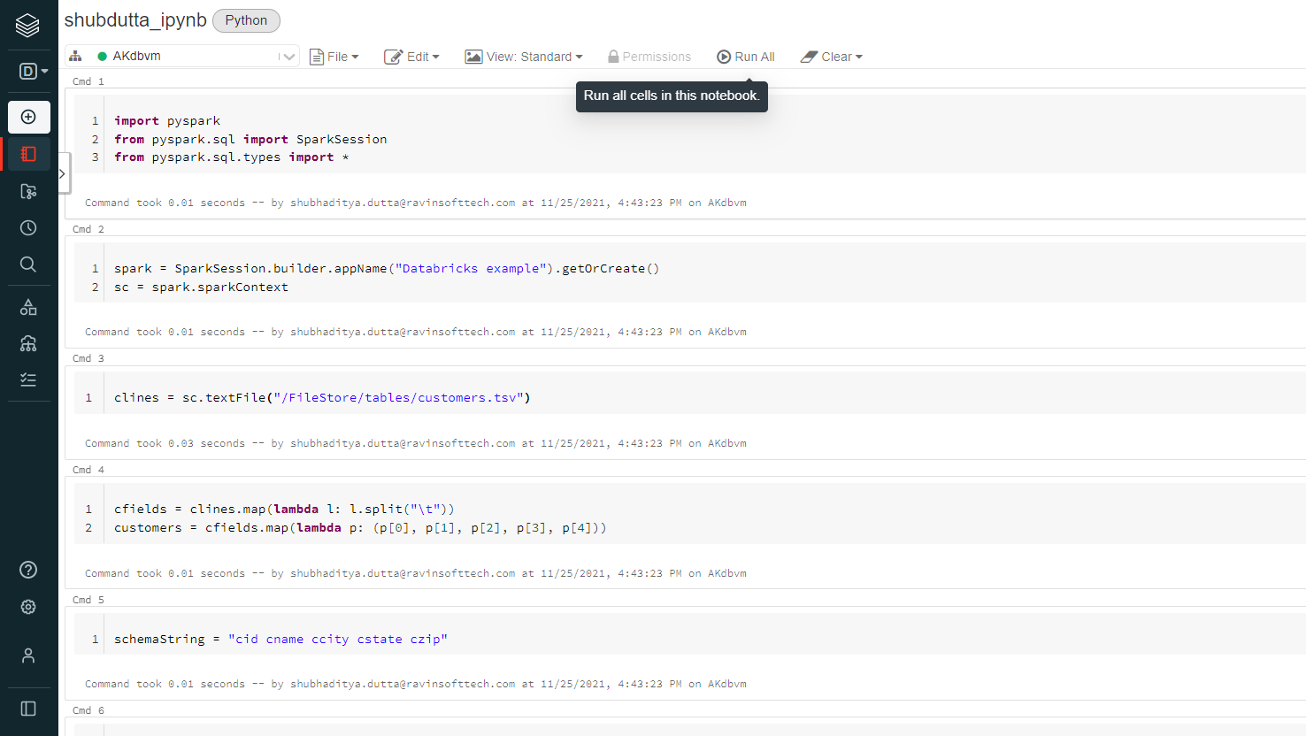

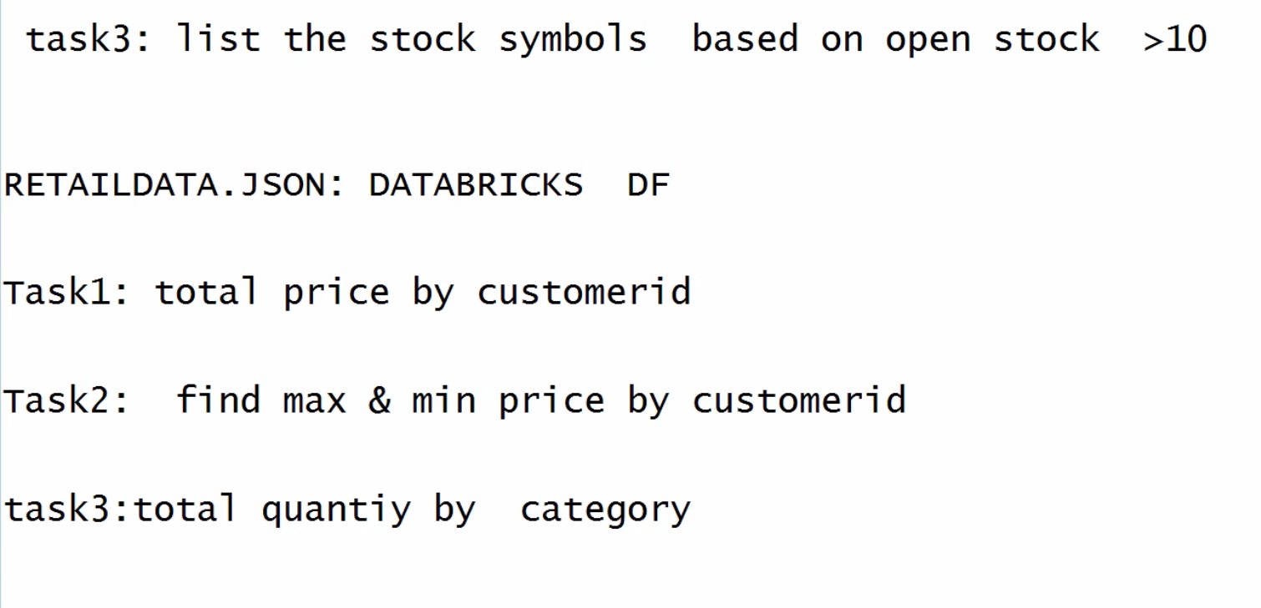

Can be done as the example executed in Databricks.